 HEALTH EXCELLENCE

Agriculture and Permaculture Company”

“Tomorrow’s world today”

**Office Number 10 First Floor.** Empire Building (Up the steps)

Corner Joshua Mqabuko Street/ 6th Avenue, **Bulawayo**

E-mail: [ndlovudingaan@gmail.com](mailto:ndlovudingaan@gmail.com) [sethumakhalima@gmail.com](mailto:sethumakhalima@gmail.com) +263 772215980/+263 784277738

_________________________________________________________________________________

**Nature of Our work/ Program**

**1:0 VISION**

To create a resilient community through skills development and financing.

**1:2 MISSION:** Reaching every member of our community and imparting knowledge and skills and causing improved quality of life through community involvement and participation.

**1:3 VALUES/ATTRIBUTES**

* Transparency –working above board
* Trustworthiness-Working in trust
* Gender sensitive-consider women, girl/boy child, youth and men
* Self-Commitment-Working under minimum supervision
* Passion-Doing what we like best for the benefit of the community without being coerced, people first

**MOTTO**

“Passion, willingness and participation”

**ACTIVITIES of our Spurt program**

**Spurt jobs with**

Business people e.g. Raj Modi

Textile industry

Confectionary

Restaurants

**OUTCOMES**

Acquisition of skills for further personal improvement.

Acquire capital for personal businesses

B) **PROJECTS AND TEAMS**

These are groups of willing individuals that engage in different projects of their choice. Numbers will range from 5-10. They will start up their small businesses through self-financing and ISALs and shall undergo training for competence and mind set change .We shall sharpen their entreprenual skills through ISALs and SACCOs training conducted by **Ministry of women affairs**.

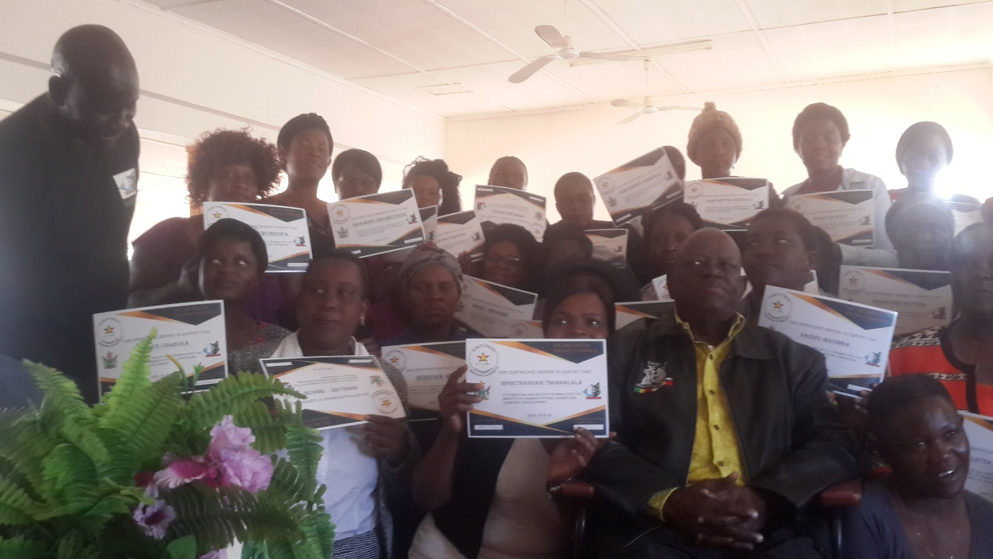

**Picture**: ***Shows women in Makokoba receiving certificates after attending Training on SACCOs and ISALs. It is our vision to train as many women in our areas of operation as possible to give them capacity.***

**TYPES OF Activities**

1) **AGRICULTURAL PROJECTS**

a. Livestock –this includes indigenous chicken production, organic goat, sheep production and breeding.

b. Cropping and horticulture

i. Diverse vegetable production

ii. Production and processing of herbs for value addition.

iii. Production of small grains and creation of Farmer Field Schools ( FFS)

iv. Acquire equipment, tool s, seeds and organic fertilizers.

***2. BACK TO SCHOOL YOUTH PROGRAM***

* Our aim is to remove as many youths from the streets as possible and rehabilitate them from other social ills such as drugs , alcohol abuse and redundancy to help them acquire survival skills and be self-sustaining

***Methodology:*** Identify youths that are out of school and create non formal attendance; classes and use spurt to pay for their tuition .Identify youths and send them to vocational training centres to acquire skills

***3. LOBBYING FOR SPURT MARKETS***

We shall deliberately lobby for acceptance of spurt as means of payment in public and private institutions e.g. local, urban and rural authorities , Zesa (electricity), schools[public and private] colleges, wholesalers ,supermarkets and hardware shops/ dealers and car dealers

Acquiring equipment and tools for our farmers

***4. HOME BASED CARE/HOME NURSING***

Taking care of the community sick, elderly, bedridden at home level and giving them the necessary care. This is our community social gesture as Makokoba and other places all over Zimbabwe. We have numerous elderly and sick who are not able to access this health service. It is our hope that we shall make an impact in their lives and reduce the burden on the shoulders of the family members. Shall work with local old people’s homes e.g. Edith duly, Ekuphumuleni, Entembeni and other charitable homes.

*Methodology:* Identify willing members of the community especially women and get them trained of First Aid and Nurse Aid and place them in our community so that they do day to day jobs and get paid in Spurt.

***5. CARE OF ORPHANS AND VULNERABLE CHILDREN***

Identifying all orphans and vulnerable children in the community and assist with paying school fees for them, buying food and clothes and other necessary things.

***6. ELDERLY***

Identify elderly women and men above 75 years of age who cannot fend for themselves and help them pay for their rentals and food (day to day needs). We shall also activate their home industry skills e.g. craft works, mats, bead work and basket making. We shall create data base for all these elderly men and women.

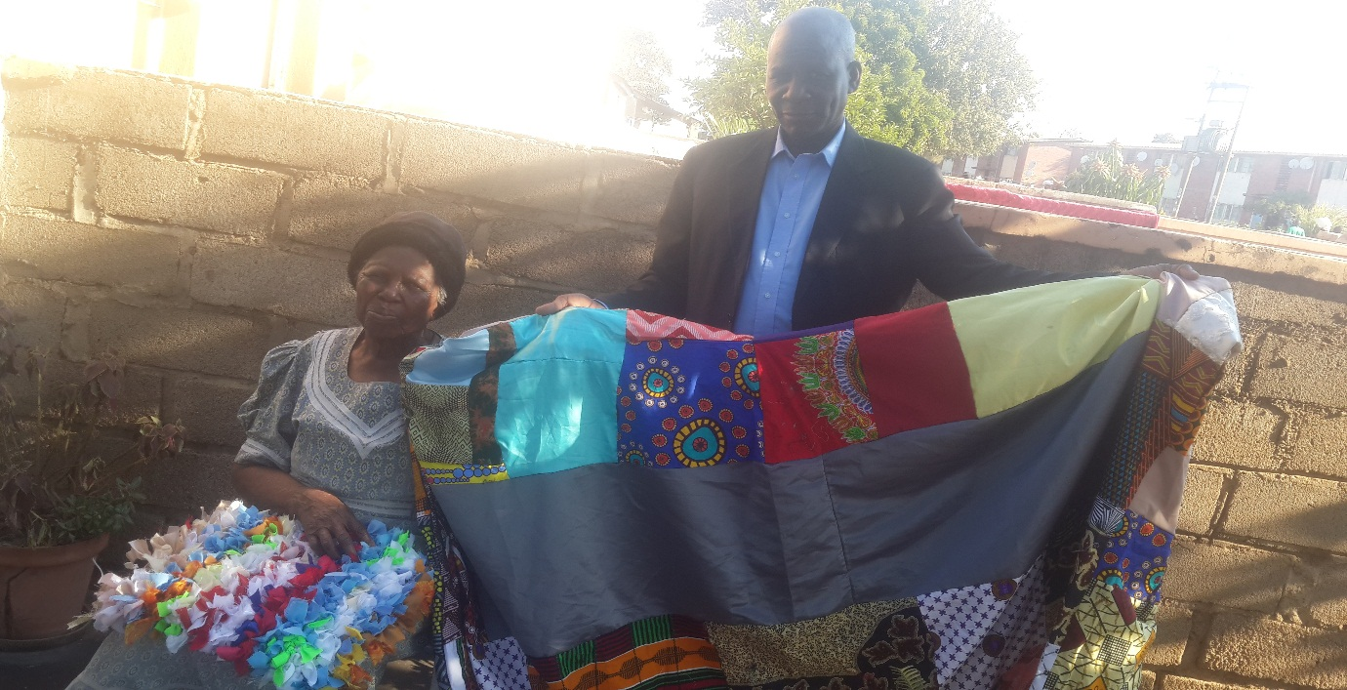

***7. COMMUNITY CLEANSING AND ENVIRONMENTAL MANAGEMENT AND RECYCLING.eg litter management***

Makokoba is specifically characterised by garbage and litter all over creating a very unsafe environment for children and everyone. It is also congested and has little space to dispose of garbage and litter. Litter accumulates at a very fast rate and need continuous attention. Makokoba is also characterised by small residential houses with more than two families sharing a room.

**Case study: Visited one house with 2 rooms and three families occupying that compartment. See photograph attached. You can see 2 beds separated by a curtain, these are 2 families sharing a room. One family is composed of a husband, wife and 3 children while the other bed is a single women with 2 children, so all 8 are sharing one room and are registered as tenants with the city council.**

STOVE

T.V.

Bed 2- 2nd family of 3

Dividing curtain

Bed 1 for 5 pple

***METHODOLOGY***

A team of willing residents shall be identified and shall take responsibility to clean the location on daily basis to create safe and more habitable environment.

We shall conduct deliberate trainings for these participants on litter management and recycling. We shall train them as community environmental monitors so that they are able to police the environment and conduct community out-reach and public clean-ups

***Picture of litter accumulating around Makokoba township- needs permanent attention***

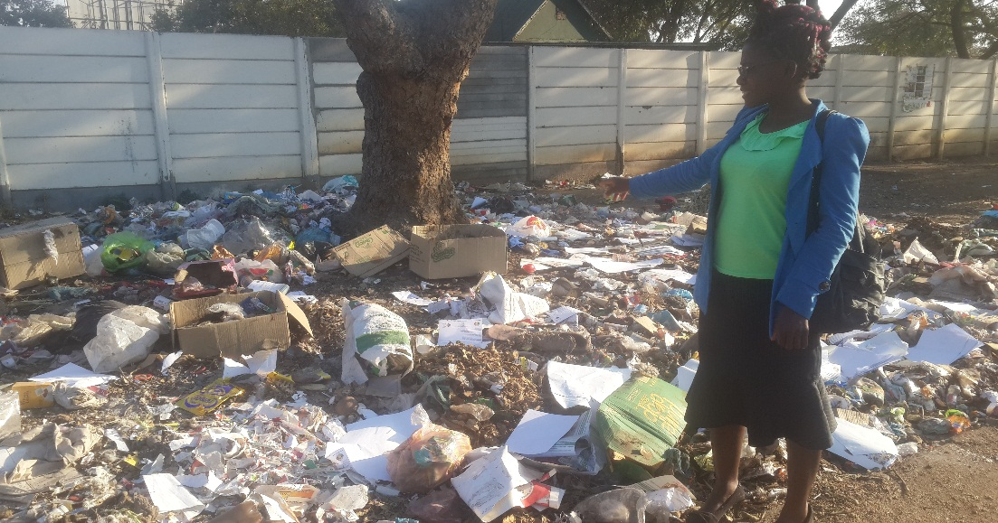

***8. PERMACULTURE IN SCHOOLS AND COMMUNITIES***

We shall identify schools within our areas of operation and enrol them in **Permaculture** training programs. Teachers, learners and parents shall be trained together and each school shall implement permaculture designs in order to create better learning environment and food production. Permaculture also addresses issues of land degradation, soil erosion and water management.

***Pic: Pictures below show children participating in the Permaculture program. Creating better schools. Mr Dingaan Ndlovu trains all schools***

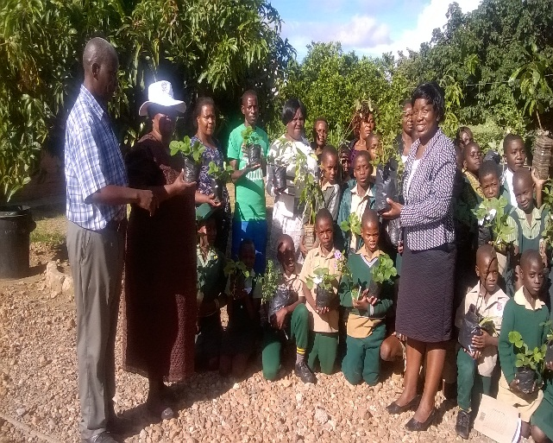 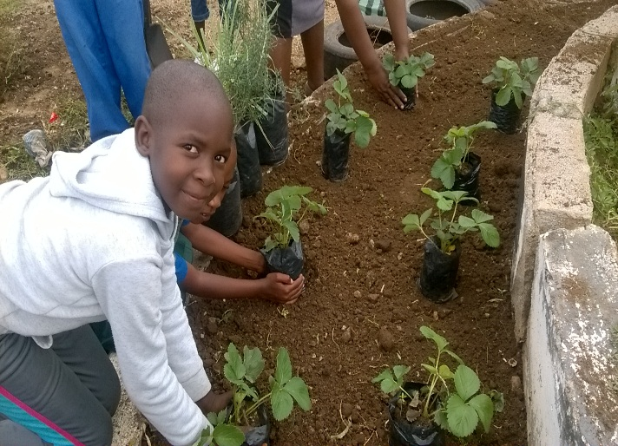

All participating teachers, learners and parents shall be enrolled in the Spurt program. All trainings shall be conducted by ***Mr. Dingaan Ndlovu*** who is a permaculture specialist.

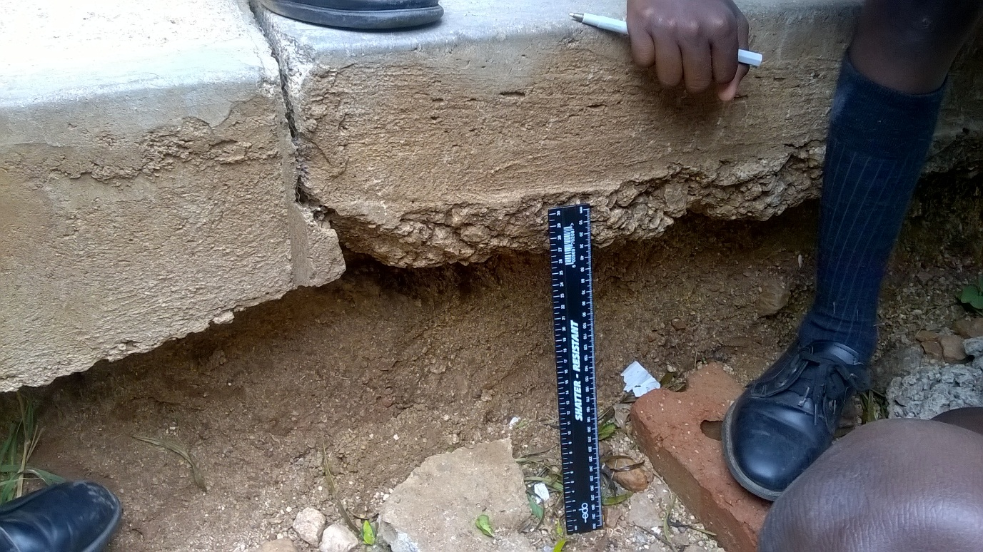

***Pic: Permaculture addresses issues of degradation and desertification***

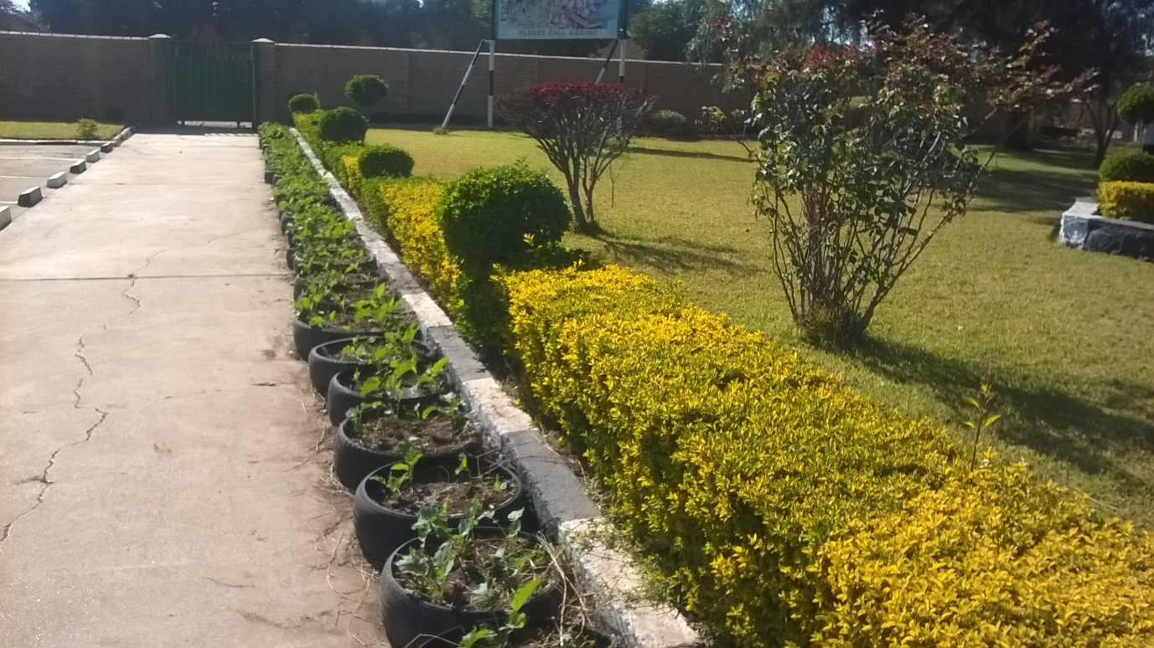

**Pic: *Permaculture addresses issues of food production and security. Tyre gardening on concrete pavements. Re-use, re cycle.***

**NB:** This program shall be replicated in all our areas where we shall operate and shall cover both urban and rural areas and shall involve extensive travelling and consultations and we shall work hand in hand with relevant authorities signing MoUs where necessary.

***COMMITMENTS***

We are committed as a team to work tirelessly and passionately for the development of our communities without prejudice and hoping that this will create better and sustainable communities.

***PARTNERSHIPS***

Our program shall work in partnership with other relevant community safety nets and other civic and charitable organisations e.g. Lions Club, Rotary Clubs , SOS and government departments.

_________________________________________________________________________________